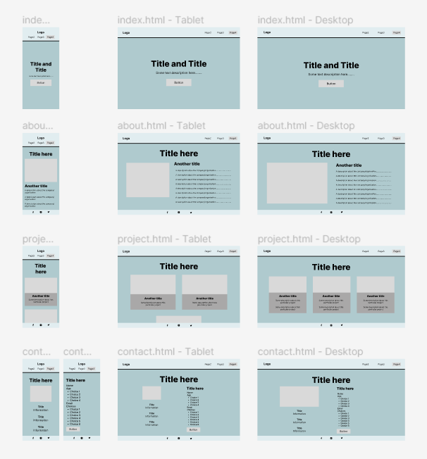

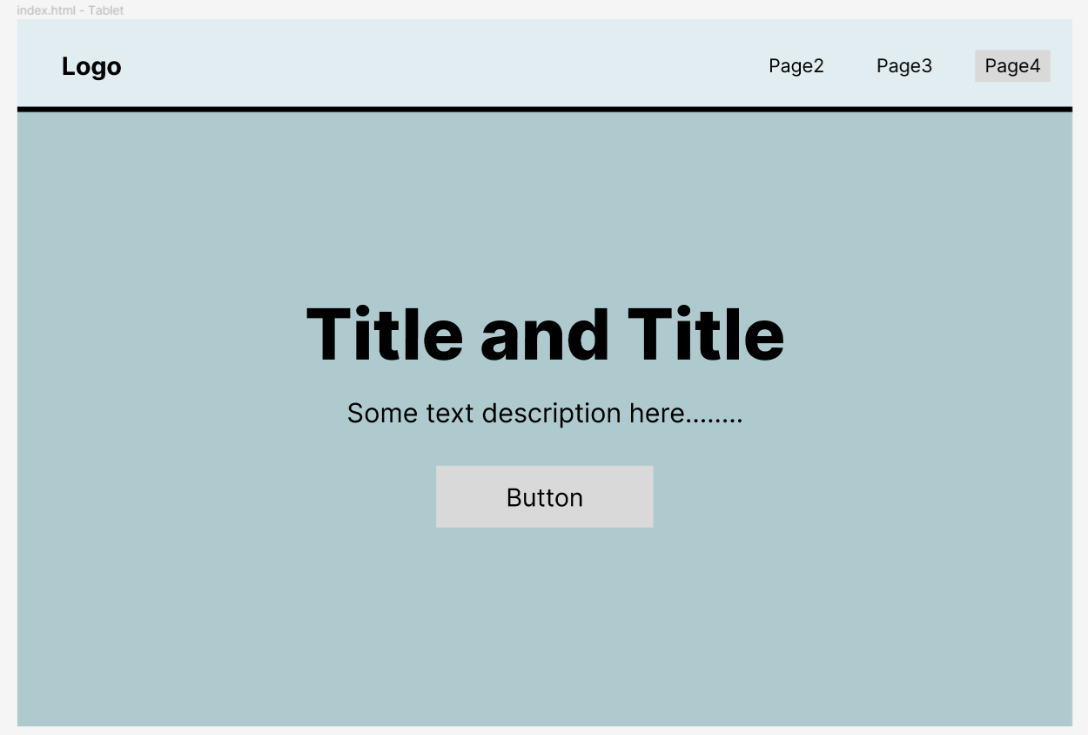

Light blue – Navigation bar

Dark blue – Background image

Grey rectangles containing words – Buttons that can be pressed to navigate to certain page

Grey button on the navigation bar – Navigate to contact information page

**Note: Purpose, labelling and colour-coding of pages in the same category (e.g. index.html) will only be explained at each mobile section to prevent redundancy).**

**index.html – Mobile, Tablet, Desktop**

This page consists of the navigation bar, a slideshow background image and content (title, description, and button)

This is the page where users will land when they access the website.

The button at the middle of the page would be an explore button that brings the user to the about page, which contains information about Loops and Love.

Light blue – Navigation bar

Dark blue – Background colour (no image)

Grey rectangle under title – An image of the founders of Loops and Love

This page is scrollable.

The footer at the bottom of the page contains links to social media pages (Facebook, Instagram, Twitter). But since it is a fictional company, the links will instead redirect to the main pages of the respective social media sites.

**about.html – Mobile, Tablet, Desktop**

This page consists of the navigation bar, a title describing what the page is about, an image of the founders of Loops and Love and introduction about Loops and Love.

The purpose is to share with the user how Loops and Love came to be, their aspirations, projects that they have done and services that they provide.

Light blue – Navigation bar

Dark blue – Background colour (no image)

Light grey rectangle – Related image of the project/function

This page is scrollable.

The footer at the bottom of the page contains links to social media pages (Facebook, Instagram, Twitter). But since it is a fictional company, the links will instead redirect to the main pages of the respective social media sites.

**project.html – Mobile, Tablet, Desktop**

This page consists of the navigation bar, a title describing what the page is about and three selection boxes that contain different project/functions that Loops and Love provide.

The purpose is to let the user browse and choose a selection to explore. There is a title and some description about the project/function, which seeks to provide user with surface information. Related image is also included to improve site aesthetic and give users an idea of what the project/function is all about.

**contact.html – Mobile, Tablet, Desktop**

This page consists of the navigation bar, a title describing what the page is about, contact information and a join us form.

The purpose is to provide the users with Loops and Love contact information and encourage them to join Loops and Love as fellow volunteers. The form section also contains a survey section which aims to find out how users found out about Loops and Love. With that, Loops and Love hopes to reach more users in the future to grow the community.

Light blue – Navigation bar

Dark blue – Background colour (no image)

Light grey rectangle – Image of crochet

1st page texts – Contact information

2nd page texts – A form consisting name, age, email and survey

Grey button – Submit form button

This page is scrollable.

There are two wireframes here to show that when scrolled down, it will display the form. When user is in this page initially, they will only see as in 1st wireframe.

The footer at the bottom of the page contains links to social media pages (Facebook, Instagram, Twitter). But since it is a fictional company, the links will instead redirect to the main pages of the respective social media sites.

